LOCATION : NATIONWIDE
DATE : 19.05.2017
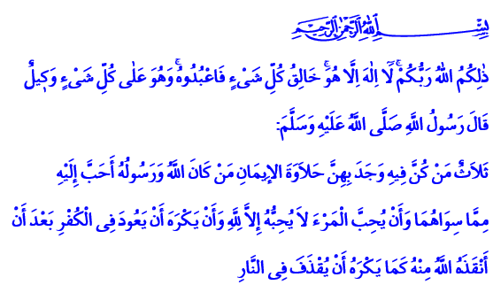
TRUE FREEDOM: SERVING ALLAH
Honorable Believers!
In the verse I have recited, the Almighty enjoins: “Allah is your Lord, there is no god but He; the Creator of all things, therefore serve Him, and He has charge of all things.”
In the hadith I have recited, our Prophet (pbuh) says: “There are three qualities for which anyone who is characterized by them will relish the savor of faith: that he loves man and he does not love him but for Allah's sake alone; he is to whom Allah and His Messenger are dearer than all else; he who prefers to be thrown into fire than to return to unbelief after Allah has rescued him out of it.”
Dear Brothers and Sisters!
The biggest goal of our religion is to elevate us with faith in Allah. To make us free with serving Him and dedicating ourselves to Him. Because in our faith, true freedom is serving Allah. True freedom is avoiding serving other servants. True will is avoiding yielding to the desires and passion of the soul.
Brothers and Sisters!
Faith is the greatest freedom. The believer is the one whose spirit is free. Because the believer only bows before his Lord. He never serves other servants. He knows that bowing before anyone other than Allah, serving other servants is slavery. The believer devotes himself to everlasting truth rather than mortal humans. He does not act blind, deaf, and silent against the truth. He does not dull his heart and will to the point of not seeing the good and right. He does not hold any love in his heart dearer than the love for Allah and His Messenger. He knows that doing that is the biggest of misdeeds. It means associating partners with Allah. And that is the greatest injustice.
Honorable Believers!
The believer endeavors to only do things that will be favored by Allah. He knows that making choices that will lead to His wrath means hurting his freedom.
The believer does not fall into the clutches of temporary blessings and deceptive joys of the world. He knows that being the slave of fancy and desire means losing freedom.
The believer is the one who is aware that he has been created as the most honorable of beings. He knows that his faith will eternalize this honor. The believer’s guidance for life is the Sublime Quran which separates right from wrong, truth from falsehood, and sin from good deed. The Prophet of Mercy, the only leader of the humankind, is the one who leads the way for the believer. A mind that contemplates Allah is what makes the believer valuable by Allah. A heart that holds Allah’s love and favor over all else. An abundant life spent with good deeds.
Honorable Brothers and Sisters!
Unfortunately, we live in a world today where material things are prioritized over spirituality and minds are tumbled by all sorts of advertisements and remarks. We are going through a period where fancy and desires are stirred up and triggered. In such a world where earning more and consuming more is encouraged, it is without a doubt that our true capital is our freedom that we have from our faith. Our true gain is our austerity stemming from our faith. Our true wealth is our good deeds, the reflection of our faith upon life. Our true superiority is our awareness of our faith and values.
Brothers and Sisters!
Before I finish my khutbah, I would like to share with you something about our mosques, the places where our servitude and devotion are manifested. Serving with the effort to reach our nation’s helping hand across the world, our Diyanet Foundation has built a great number of mosques with your help in our country and region of affection from past to present. Your help will be asked for today at mosques nationwide for the Cyprus Hala Sultan Mosque, Kyrgyzstan Bishkek Mosque, Albania Tirana Central Mosque, Djibouti Sultan Abdulhamit Han II Mosque and Complex. May the Almighty accept all the help you have given and will give. May He grant us to be among those honored by the news in the hadith “Whoever builds a mosque for Allah, Allah grants him a similar mansion in paradise.” May He make our mosques build hearts, reinforce our unity and brotherhood, and elevate our dignity and honor.
I would like to finish my khutbah with this verse: “(O Muhammad!) Say: ‘What would my Lord care for you if not for your supplication?’”

Al-An’am, 6/102.
Muslim, Îmân, 67.
Al-Baqarah, 2/54, 57; Al-A’raf, 7/177; Hud, 11/101.
Muslim, Zühd, 44.
Al-Furqan, 25/77. Written by: General Directorate of Religious Services

